Testing Concurrent Applications

Testing is an important tool during the development process to create high quality applications. In the past, when concurrency was not such an important part of application architecture, testing was straightforward. Over the past few years it has become more and more important to use concurrent design patterns and we were challenged to develop new best practices to test them.

在开发高质量应用程序的时候，测试是一个很重要的工具。在过去，并发在应用程序架构中还没有那么重要，测试就相对简单。随着这几年的发展，并发设计模式已愈发重要了，想要测试好，已成了一个不小的挑战.

The main challenge of testing concurrent code is that the program or information flow is not reflected in the call stack any more. Functions do not return their result to the caller immediately, but deliver it later via callback functions, blocks, notifications, or similar mechanisms, which makes testing more difficult.

测试并发代码最主要的困难在于程序或者信息流不再反映在调用堆栈上了。函数并不会立即返回给调用者结果，而是通过回调函数，闭包（Block），通知或者一些类似的机制来推迟返回结果，这就让测试变得更困难

However, testing asynchronous code comes with the benefit of uncovering poor design decisions and facilitating clean implementations.

然而，测试异步代码也会带来一些好处，比如可以提早暴露一些较差的设计决定，让最终的实现变得更加清晰。

The Problem with Asynchronous Testing

Let’s first recall an example of a simple synchronous unit test. This method of a simple calculator should sum up two numbers:

首先，我们来看一个简单的同步单元测试。两个数求和。

+ (int)add:(int)a to:(int)b { return a + b; }

Testing this method is as simple as calling the method and comparing the result to the expected value. If the values don’t match, the test fails.

测试这个方法很简单，只需要比较该方法返回的值和期望的值是否相同，不相同，则测试失败。

- (void)testAddition { int result = [Calculator add:2 to:2]; STAssertEquals(result, 4, nil); }

Now let’s change the method to return its result asynchronously via a completion block. We will also add a bug to the implementation, so that we can expect a failing test:

接下来，利用Block将该方法改变成异步返回结果。当然了，我们也会添加一个Bug,让测试失败。

+ (int)add:(int)a to:(int)b block:(void(^)(int))block { [[NSOperationQueue mainQueue] addOperationWithBlock^{ block(a - b); // Buggy implementation }]; }

Of course this is a contrived example, but it reflects the general pattern you would use often if the operation would be more computationally intensive.

虽然这是一个人为的例子，但是它却真实的反应了在编程中遇到的问题，只不过实际过程更复杂罢了。

A naive approach to testing this method would just move the assertion into the completion block. However, such a test simply never fails, in spite of the bug in our implementation:

把断言放到Block的实现中来测试该方法是一种想当然的方式。然而，这种情况下，测试不会失败，Bug却依然存在。

// don't use this code! - (void)testAdditionAsync { [Calculator add:2 to:2 block^(int result) { STAssertEquals(result, 4, nil); // Never fails! }]; }

Why doesn’t this assertion fail?

为什么断言不会失败呢

SenTestingKit Under the Hood

The testing framework used by Xcode 4 is based on [OCUnit](http://www.sente.ch/software/ocunit/), which allows us to have a closer look at the internals. To understand the problem with the asynchronous test, we need to have a look at the execution order of the different parts of the test suite. This diagram shows a simplified flow.

XCode4使用的测试框架是基于开源的[OCUnit](http://www.sente.ch/software/ocunit/), 为了能更好的理解异步测试，我们需要了解一下各种测试方法之间执行顺序的不同。下图展示了一个简化的流程。

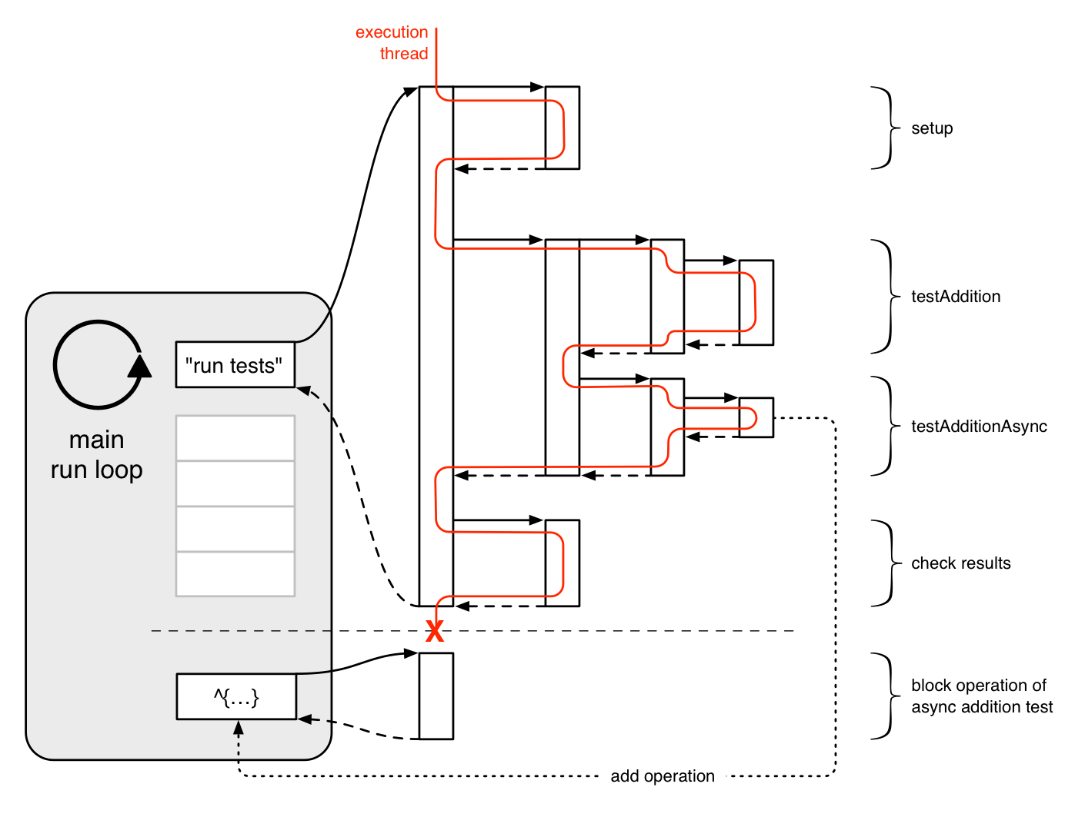

After the testing kit is started on the main run loop, it executes the following main steps:

测试程序从主 run loop开始后，执行顺序主要有以下几步

1. It sets up a test suite containing all relevant tests (as specified e.g. in the project scheme).

配置一个测试套件包含所有的测试(在工程的scheme中配置)

1. It runs the suite, which internally invokes all methods of the test cases starting with*test*. This run returns an object, containing the results of each single test.

运行测试套件，其主要功能就是调用以test开头的所有方法。运行结束后会返回一个对象，它包含之前执行的所有测试的结果。

1. It exits the process by calling exit().

调用exit()方法，退出测试。

The interesting part is how each individual test is invoked. During the asynchronous test, the completion block containing the assertion gets enqueued on the main run loop. Since the testing framework exits the process after all tests run, this block never gets executed and therefore never causes the test to fail.

这其中重要的是单个测试方法是如何被调用的。在异步测试中，block中包含的断言是放在主run loop中，当所有的测试执行完毕后，测试框架就会结束该进程，而block却从来没有被执行，因此不会触发测试失败。

There are several approaches to solve this problem. But all of them have to run the main run loop and handle the enqueued operations before the test method returns and the framework checks the result.

当然有很多种方式来解决这个问题，核心思想就是运行主run loop,在框架检查测试结果之前完成入队列的操作。

[Kiwi](https://github.com/allending/Kiwi) uses a probe poller, which can be invoked within the test method. [GHUnit](https://github.com/gabriel/gh-unit/)provides a separate test class, which has to be prepared within the test method and which needs a notification at the end. In both cases we have to write some code, which ensures that the test method will not return until the test finishes.

[Kiwi](https://github.com/allending/Kiwi)用轮询的方式来解决，其本质就是在测试方法内反复调用。[GHUnit](https://github.com/gabriel/gh-unit/)用一个单独的测试类，它会在测试方法内初始化，结束时发送一个通知。这两种方式都是通过代码来确保异步测试方法在测试结束之前都不会返回。

Async Extension to SenTestingKit

Our solution to this problem is an [extension](https://github.com/nxtbgthng/SenTestingKitAsync) to the built-in testing kit, which winds up the synchronous execution on the stack and enqueues each part as a block on the main queue. As you can see in the diagram below, the block that reports the success or failure of the asynchronous test is enqueued before the results of the entire suite are checked. This execution order allows us to fire up a test and wait for its result.

我们的解决方式添加一个[extension](https://github.com/nxtbgthng/SenTestingKitAsync)  .正如下图所见，验证异步测试失败或者成功的方法被放在一个block内，它在框架查看测试结果之前被加入到了主队列中。这种执行顺序允许我们开启一个测试并等待它的测试结果。

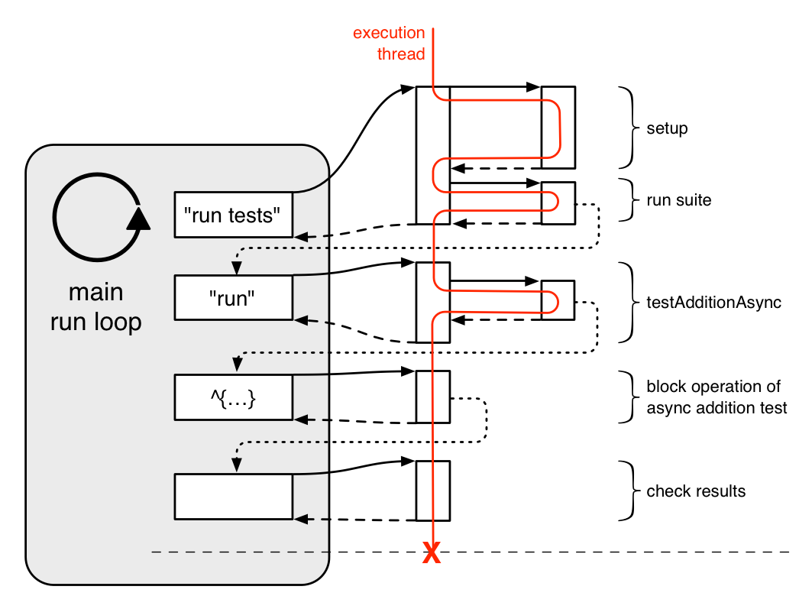

To give the framework a hint that a test should be treated as asynchronous, the method name has to end with **Async**. Furthermore, in asynchronous tests, we have to report the success of the test case manually and include a timeout, in case the completion block never gets called. We can rewrite our faulty test from above like this:

测试方法以Async结尾，框架就会认为该方法是异步测试。在异步测试中，我们在Block中添加一个宏来表示测试成功，为了防止Block永远不会被调用，我们还添加了一个超时方法。之前的测试函数修改后如下所示：

- (void)testAdditionAsync { [Calculator add:2 to:2 block^(int result) { STAssertEquals(result, 4, nil); STSuccess(); // Calling this macro reports success }]; STFailAfter(2.0, @"Timeout"); }

Designing Asynchronous Tests

设计异步测试

As with their synchronous counterparts, asynchronous tests should always be a magnitude simpler than the implementation they are testing. Complex tests don’t promote better code quality, because the possibility of bugs in the tests increases. In a test-driven development process, simple tests let us think more clearly about the borders of components, their interfaces, and the expected behavior of the architecture.

就像同步测试一样，异步测试也应该比被测试的功能更简单。复杂的测试并不会改进代码的质量，相反，会给测试本身带来Bug.在以测试开发优先的情况下，简单的测试会让我们对组件，接口以及架构的行为有更清醒的认识。

Example Project

To put all this into practice, we create an example framework called [PinacotecaCore](https://github.com/objcio/issue-2-async-testing), which requests information of images from a hypothetical server. It has a resource manager, which is the developer-facing interface, providing a method to get an image object with an image id. In the background, the resource manager fetches the information from the server and updates the properties in the database.

综上所述，

Although this is only an example project for the sake of demonstration, it shares the pattern we use in several of our apps.

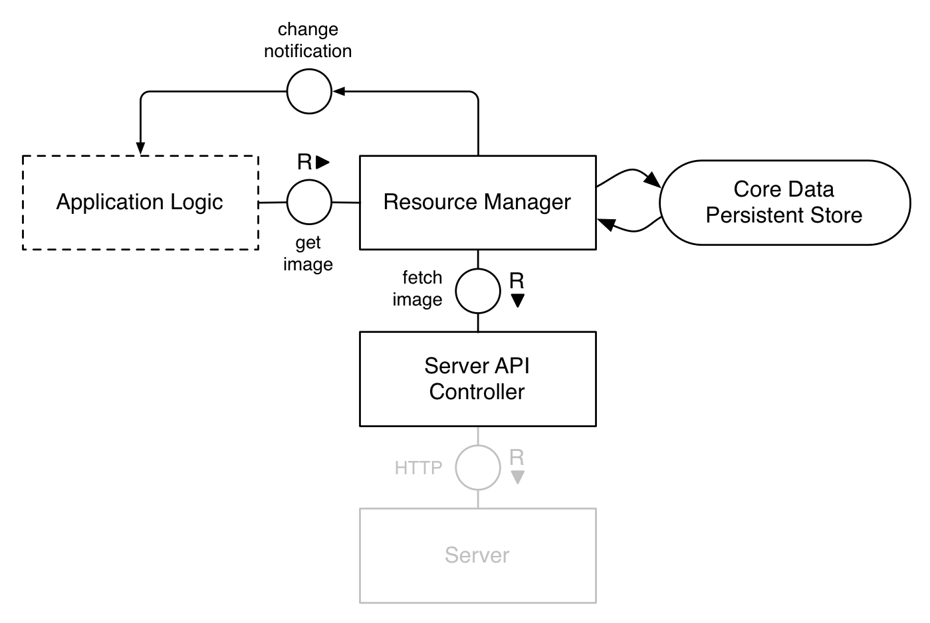

With this high level overview of the architecture we can dive into the tests of the framework. In general there are three components which should be tested:

1. the model layer
2. the server API controller, which abstracts the requests to the server
3. the resource manager, which manages the core data stack and ties the model layer and the API controller together

Model Layer

Tests should be synchronous whenever possible, and the model layer is a good example. As long as there are no complicated dependencies between different managed object contexts, the test cases should set up their own core data stack with a context on the main thread in which to execute their operations.

像模型层就尽量用同步的方式来测试。在不同的被管理的对象上下文中，只要没有太多的依赖，测试应该根据上下文在执行操作的主线程上设置它自己core data堆栈，

In this example, the [test case](https://github.com/objcio/issue-2-async-testing/blob/master/PinacotecaCore/PinacotecaCoreTests/PCModelLayerTests.m) sets up the core data stack in setUp, checks if the entity description for PCImage is present, creates an object with the constructor, and updates its values. As this has nothing to do with asynchronous testing, we won’t go into further details here.

在这个例子中，我们就是在setUp方法中设置core data堆栈，然后检查PCImage对象是否存在，不存在则构造一个，并更新它的值。当然了，这和异步测试没有关系，我们就不深入细说了。

Server API Controller

The second building block of the architecture is the server API controller. It contains the logic to manage the mapping of the server API to the model and handles the requests. In general, we want to evaluate the behavior of the following method:

第二个要讨论的Block架构是服务器接口控制器。它由处理服务器请求，服务器API到模型的映射关系这两部分构成。

- [PCServerAPIController fetchImageWithId:queue:completionHandler:]

It should be called with the id of an image and call the completion handler on the given queue.

调用他需要传入一个图片对象，所在的执行队列以及一个完成后的回调函数。

Because the server doesn’t exist yet, and because it’s a good habit, we will stub the network request with [OHHTTPStubs](https://github.com/AliSoftware/OHHTTPStubs). With the newest version, the project can contain a bundle with example responses, which will be delivered to the client.

当服务器根本不存在时，一个比较好的做法就是伪造一个代理服务器，正好[OHHTTPStubs](https://github.com/AliSoftware/OHHTTPStubs)可以解决这个问题。在它的最新版本中，可以在请求响应中包含一个bundle，发送给客户端。

To stub a request, OHHTTPStubs has to be configured either in our test setup or in the test itself. First we have to load the bundle containing the responses:

为了能接管请求，在测试类初始化或者setUp方法中，对OHHTTPStubs进行配置。首先，我们初始化一个包含请求响应对象（response）的bundle.

NSURL *url = [[NSBundle bundleForClass:[self class]] URLForResource:@"ServerAPIResponses" withExtension:@"bundle"]; NSBundle *bundle = [NSBundle url];

Then we can load the response from the bundle and specify for which request it should be returned:

然后我们从bundle中加载请求响应对象（response）,作为请求的响应值。

OHHTTPStubsResponse *response; response = [OHHTTPStubsResponse responseNamed:@"images/123" fromBundle:responsesBundle responseTime:0.1]; [OHHTTPStubs stubRequestsPassingTest:^BOOL(NSURLRequest *request) { return YES /* true, if it's the expected request */; } withStubResponse:^OHHTTPStubsResponse *(NSURLRequest *request) { return response; }];

With this setup, the simplified version of the [API controller test](https://github.com/objcio/issue-2-async-testing/blob/master/PinacotecaCore/PinacotecaCoreTests/PCServerAPIControllerTests.m) looks like this:

设置之后，控制器测试的简化版本如下所示：

- (void)testFetchImageAsync { [self.server fetchImageWithId:@"123" queue:[NSOperationQueue mainQueue] completionHandler:^(id imageData, NSError *error) { STAssertEqualObjects([NSOperationQueue currentQueue], queue, nil); STAssertNil(error, [error localizedDescription]); STAssertTrue([imageData isKindOfClass:[NSDictionary class]], nil); // Check the values of the returned dictionary. STSuccess(); }]; STFailAfter(2.0, nil); }

Resource Manager

The last component is the resource manager, which ties the model layer and the API controller together and manages the core data stack. Here we want to test the method to get an image object:

最后一个组件是资源管理器，它把API控制器和模型层联关联起来

-[PCResourceManager imageWithId:usingManagedObjectContext:queue:updateHandler:]

This method should return an image object for the given id. If this image is not in the database, it will return a new object containing only the id and call the API controller to request the detailed information.

Since the test of the resource manager should not depend on the API controller, we will stub it with [OCMock](http://ocmock.org/), which is ideal for partial stubs of methods. This is done in the [resource manager test](https://github.com/objcio/issue-2-async-testing/blob/master/PinacotecaCore/PinacotecaCoreTests/PCResourceManagerTests.m):

OCMockObject *mo; mo = [OCMockObject partialMockForObject:self.resourceManager.server]; id exp = [[serverMock expect] andCall:@selector(fetchImageWithId:queue:completionHandler:) onObject:self]; [exp fetchImageWithId:OCMOCK_ANY queue:OCMOCK_ANY completionHandler:OCMOCK_ANY];

Instead of calling the real method of the API controller, the test will use the method implemented in the test case itself.

With this in place, the test of the resource manager is straightforward. It calls the manager to get a resource, which internally will call the stubbed method on the API controller. There we can check if the controller is called with the correct parameters. After invoking the result handler, the resource manager updates the model and will call the result handler of our test.

- (void)testGetImageAsync { NSManagedObjectContext *ctx = self.resourceManager.mainManagedObjectContext; __block PCImage *img; img = [self.resourceManager imageWithId:@"123" usingManagedObjectContext:ctx queue:[NSOperationQueue mainQueue] updateHandler:^(NSError *error) { // Check if the error is nil and // if the image has been updated. STSuccess(); }]; STAssertNotNil(img, nil); STFailAfter(2.0, @"Timeout"); }

Conclusion

Testing applications using concurrent design patterns can be challenging at first, but once you understand the differences and establish best practices, it is easy and a lot of fun.

测试并发设计模式开发的应用程序是一个挑战，但是一旦你理解了它们的不同，并建立最佳实践，一切都会变得简单而有趣。

At [nxtbgthng](http://nxtbgthng.com/) we are using the process described, [SenTestingKitAsync](https://github.com/nxtbgthng/SenTestingKitAsync), on a daily basis. But the other approaches, like [Kiwi](https://github.com/allending/Kiwi) or [GHUnit](https://github.com/gabriel/gh-unit/), are also good ways of doing asynchronous testing. You should try them all, find your preferred tool, and start testing asynchronously.

在[nxtbgthng](http://nxtbgthng.com/)项目中，我们用[SenTestingKitAsync](https://github.com/nxtbgthng/SenTestingKitAsync)框架来测试。但是像[Kiwi](https://github.com/allending/Kiwi) 和[GHUnit](https://github.com/gabriel/gh-unit/)也都是不错的异步测试框架。你可以都试用一下，找到适合自己的工具进行异步测试。